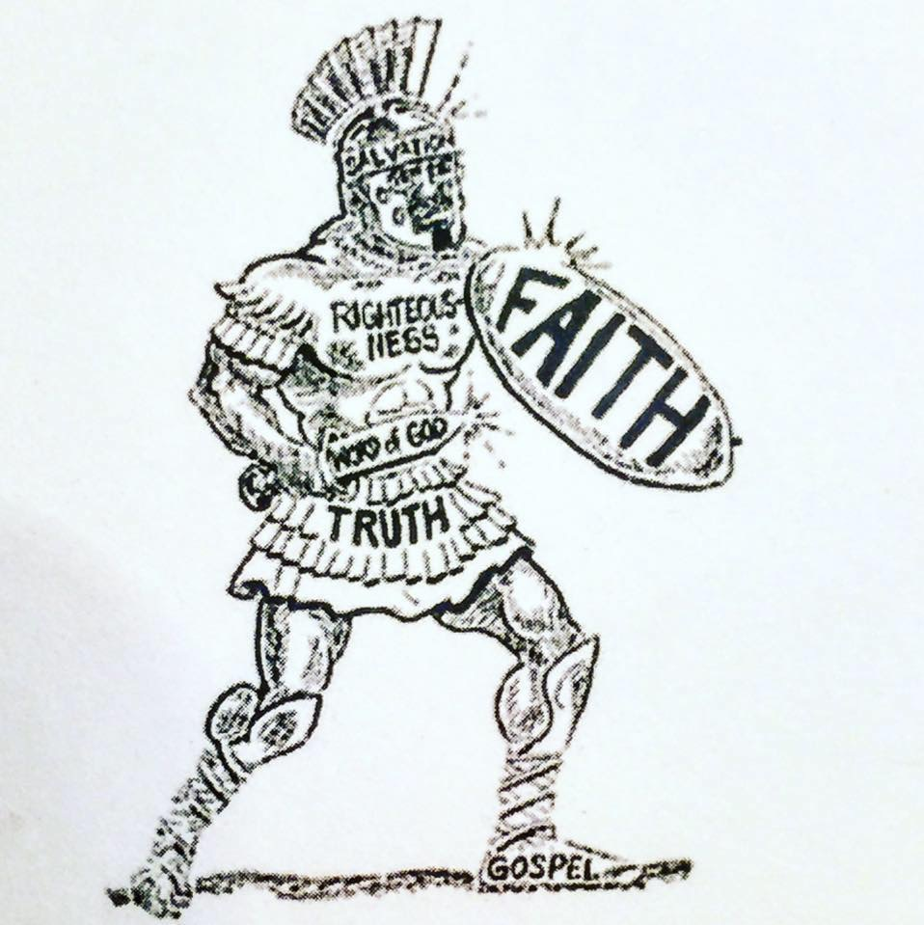 | Recovery Soldiers Ministries

Ministry Staff / Volunteer Application

Personal Information
Full Name:
 | Last | First | M.I.

Address:
 | Street Address | Apartment/Unit #

 | City | State | ZIP Code

Home Phone: |  | Alternate Phone:

Email
SSN or Gov’t ID:

Birth Date: |  | Marital Status:

Spouse’s Name:

Spouse’s Employer: |  | Spouse’s Work Phone:

Job Information
Title: |  | Employee ID:
Supervisor: |  |  | Department:
Work Location: |  |  | Email:
Work Phone: |  |  | Cell Phone:
Start Date: |  |  | Salary: | $

Emergency Contact Information
Full Name:
 | Last | First | M.I.

Address:
 | Street Address/City/State/Zip | Apartment/Unit #

Primary Phone: |  | Alternate Phone:
Relationship:
LEGAL STATUS
Have you ever been arrested? Yes No How many times?
Date | Charges | Convicted(y/n) | Sentence | Time Served
Do you have any felony charges? Yes No
Have you ever been convicted of any Violent Crimes? Yes No
If Yes for what?
Have you ever been convicted of a sex crime? ? Yes No
(Falsifying this question will result in immediate termination from the program, and you may be legally responsible for any consequences that may occur due to your falsification)
If Yes for what?
What pending charges? Court Date:
Have you ever been on proation? Yes No
Are you curently on probation? Yes No How Long/Time Remaining?
How do you report? In Person By Mail Phone How Often?
Name of probation officer: Phone#:
Adress:
City: State: Zip:
Have you ever been in prison? Yes No When? Where?
Name of Lawyer: Phone#:
Adress:
City: State: Zip:

Recovery Soldiers Ministries
ENVIROMENT: NICOTINE-FREE WORKPLACE POLICY

Recovery Soldiers Ministries is committed to providing a safe and healthy workplace and to promoting the health, wellbeing and full recovery for students, volunteers, and staff. We believe true recovery is true freedom from ALL bondages. Because we are teaching true freedom, we must all abide by the same rules and guidelines. Therefore, the following Nicotine-Free policy has been adopted and shall apply to all employees, volunteers, and students of Recovery Soldiers Ministries.
NICOTINE-FREE POLICY: No smoking or other use of nicotine products including, but not limited to, cigarettes, pipes, cigars, snuff, chewing tobacco, or any type of vape smoking is permitted by students, volunteers, and employees who belong to Recovery Soldiers Ministries.
Students or Employees who violate this smoking policy will be subject to disciplinary action up to and including immediate discharge at the discretion of the directors.

STATEMENT OF UNDERSTANDING
I have read and fully understand the terms of this policy.
I understand that any violation of this smoking policy will be subject to disciplinary action up to and including immediate discharge at the discretion of President, Program Director, and or Executive Director.
I understand that Recovery Soldiers Ministries reserves the right to make changes to this policy as may be required.

Printed Name Date

Signature Date

